Build a Docker Image Using a Custom Dockerfile
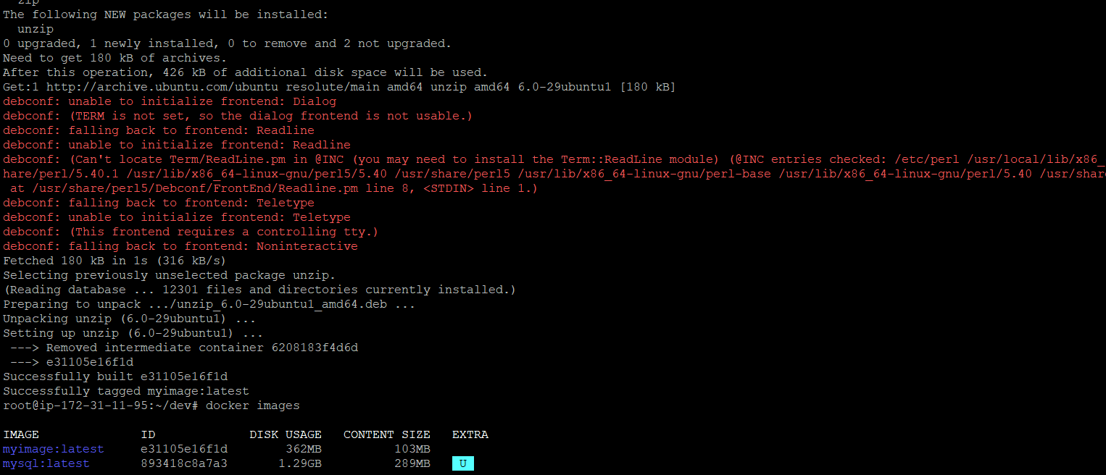

docker run -itd --name myowncontainer -p "8087:80" myimage
docker exec -it a956b02ed6ee /bin/bash
vim
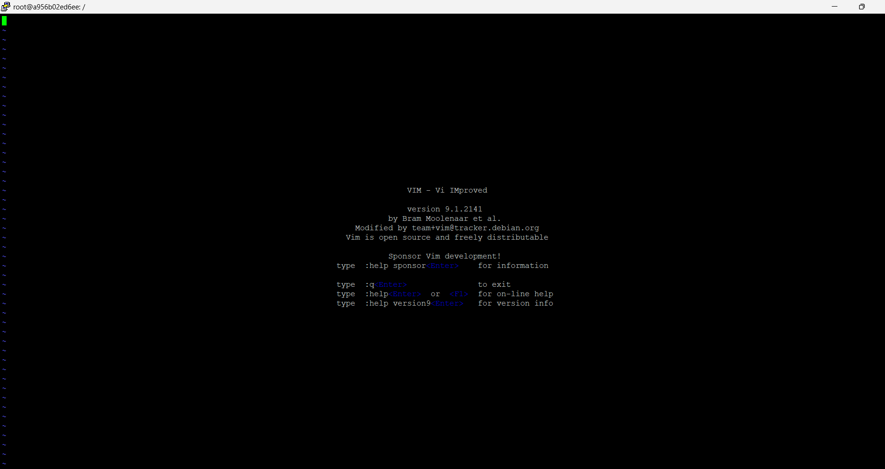

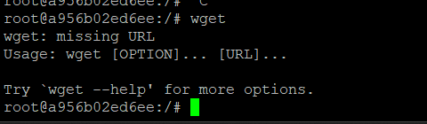
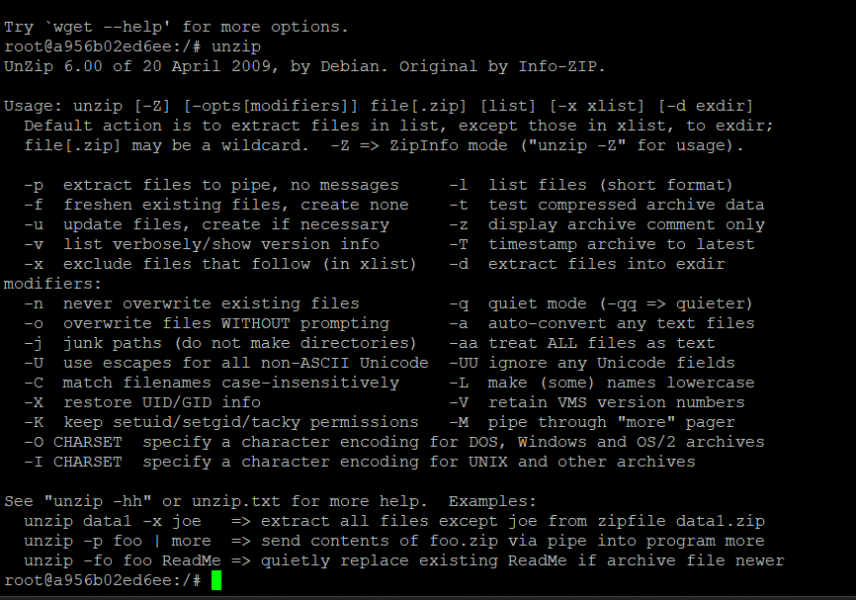

After removing unzip and installing php
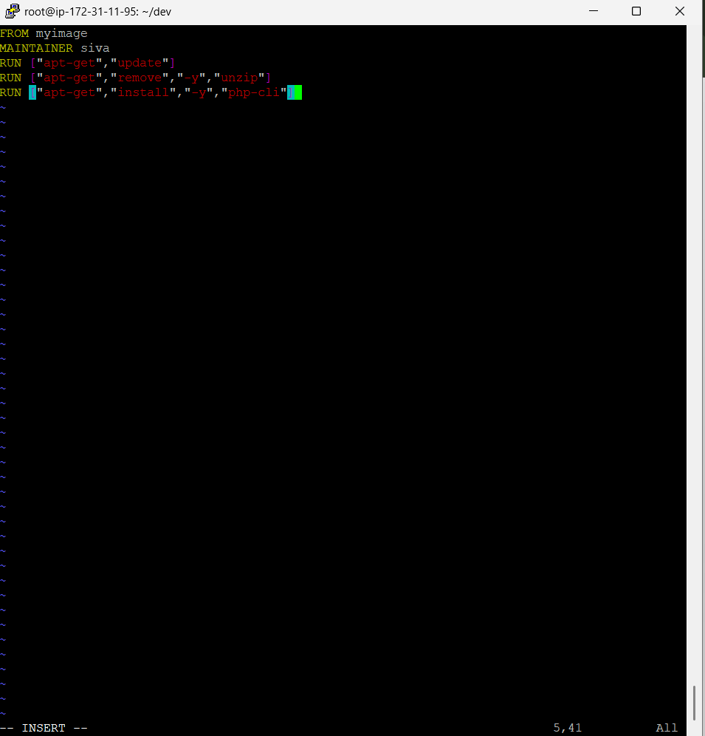
docker rm -f a956b02ed6ee
a956b02ed6ee
docker run -itd --name myowncontainer -p "8087:80" myimage
